**MINISTRY/ORGANIZATION NAME:** FCRIT, Vashi.

**PROBLEM STATEMENT:** Portal for Farmers to sell the product at a better rate.

• Problem statement in Description

1. System that provides farmers an interface to sell their product, and connect with the buyers all over India

2. Simple interface that works on mobile, MS to upload product details and respond via phone and SMS (taking care of digital divide)

3. Interface for anyone to buy the produce/vegetable – initially visit the place and buy or have courier service integrated to deliver the vegetables so Farmers can get a better price for their produce, no additional cost spent in marketing and delivery of goods, however they can choose to charge more by delivering the items themselves.

**TEAM NAME:** Agrocraft.

**TEAM LEADER NAME:** Abhishek Gupta.

|  |  |  |  |
| --- | --- | --- | --- |
| Name | Gender | Email id | Phone |
| Abhishek Gupta | Male | abhig0209@gmail.com | 8169193145 |
| Gladina Raymond | Female | rrcg2000@gmail.com | 9820835824 |
| Omkar Bhabal | Male | omkarbhabal11@gmail.com | 8828071232 |
| Calista Gonsalves | Female | gonsalvescalista21@gmail.com | 8369051225 |
| Ansh Chhadva | Male | anshmiteshchhadva@gmail.com | 9819104641 |
| Arpit Bhat | Male | arpitbhat48@gmail.com | 7666610976 |

**COLLEGE CODE:**

**IDEA/SOLUTION/PROTOTYPE:**

**Agrocraft is an online portal with a pure vision to consolidate farmers and consumers/buyers. Farmers can upload their products online with their market value and the buyers can buy the fresh products direct from the farm easily.**

1. Farmers undergo the scrutiny of middlemen (traders), losing 75% of their output to them, whereas in the meagre amount left, he faces a couple of monetary challenges(paying for pesticides, agricultural equipment). **Agrocraft enables to eliminate this intermediary broker and gives the farmer fair and licit revenue for his yield.**
2. Farmers pay a hefty delivery fee, on a daily basis, which significantly scars their pockets. **Agrocraft, becomes the delivery service and supplies the produce to the consumers and buyers, and liberates the farmer from the colossal delivery fee.**
3. In more than one cases, scarcity of a specific product is noticed at a particular location. **Agrocraft bridges this problem of lack, ( I don’t know how) and enables even distribution.**
4. Farmers in remote areas have no idea of the prevalent market prices. **Agrocraft works in indoctrinating these lost farmers with the current situation in the market, uplifts them by linking them straight to the buyers and gets them in the game.**

**FEATURES:**

1. Sms Product upload , update,delete
2. Call centres upload , update,delete
3. Simple interface for farmers.
4. Farmer can suggest their own price, in regards with the market price.
5. Buyers get a larger scope for selecting choicest products from all around India.
6. Buyer can buy product on the basis of review system.
7. Reporting system.
8. Subscription.
9. Chat system.
10. Multi lingual portal.
11. Demands and Price predictions,
12. Verification farmers
13. Verification products
14. Recommendation system.(Smart basket)
15. Bestsellers
16. Search Engine & Categorical Search
17. Trust Coin.
18. Product Search via Location (State and District Wise)
19. Courier System Integration.
20. The above portal envelops every aspect in terms of functionality, feasibility, practicability.
21. Enhancing Searching through filters

**TECHNOLOGY STACK:**

1. Web Technology: - HTML, CSS, PHP, JavaScript, AJAX, Bootstrap and Django.

2. Programming languages: - Python and Java.

3. Mobile Development:-Android Studio, Android SDK and Jellybean.

4. Backend Development:-My SQL Database and Firebase.

**USE CASE :-**

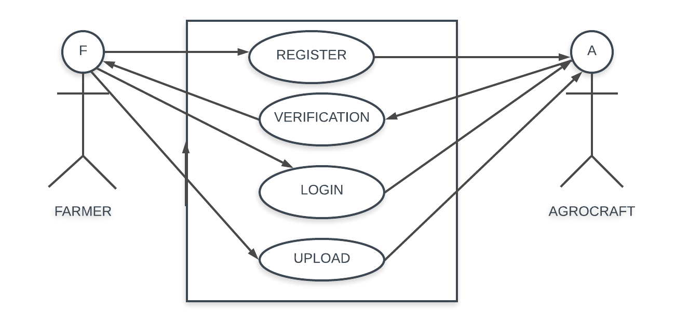

**DEPENDENCIES:-**

1. The farmer must possess a basic phone.

2. This application can be installed in all devices having Android version Jellybean and higher.

3. An online portal generated shall require IE v9 or higher, Google Chrome, Mozilla Firefox, or any other web browser.

**SHOWSTOPPERS:-**

1. Call Centres.

2. SMS

3. Farmer profits increases owing to the fact that farmers sell their products at market rates, eliminating the middleman.

4. Buyers can get their hands directly on fresh products according to their choice of product, variety and time, straight from the fields in reasonable prices.

5. Multiple farmers (many of which reside in remote areas) get in direct touch with buyers in capital cities and the prices are negotiable between them with no involvement of the admin whatsoever.